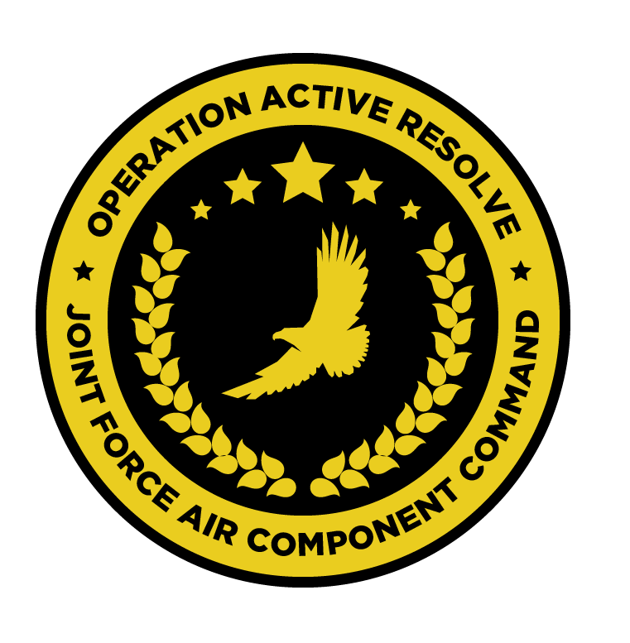

JFACC AIR OPERATIONS DIRECTIVE

OPERATION ACTIVE RESOLVE

D+3

# 1. SITUATION

## a. JFC guidance (verbatim).

See [CJTF Operations Order](https://132nd-vwing.github.io/OPAR-Brief/ORDERS/OPAR%20CJTF82%20OPERATION%20ORDER.pdf)

## b. Enemy situation.

[VIS INTSUM Ground](https://132nd-vwing.github.io/OPAR-Brief/INTELLIGENCE/INTSUM/VIS_INTSUM_D2_Ground.pdf) , [VIS INTSUM AIR](https://132nd-vwing.github.io/OPAR-Brief/INTELLIGENCE/INTSUM/VIS_INTSUM_D2_AIR.pdf) , [VIS INTSUM IADS](https://132nd-vwing.github.io/OPAR-Brief/INTELLIGENCE/INTSUM/VIS_INTSUM_D2_IADS.pdf)

## c. Friendly situation (by joint force component).

See [CJTF Operations Order](https://132nd-vwing.github.io/OPAR-Brief/ORDERS/OPAR%20CJTF82%20OPERATION%20ORDER.pdf) and [LCC III Corps Conops](https://132nd-vwing.github.io/OPAR-Brief/ORDERS/OPAR%20LCC%20III%20CORPS%20CONCEPT%20OF%20OPERATIONS%20PHASE%201.pdf) and [LCC IV Corps Conops](https://132nd-vwing.github.io/OPAR-Brief/ORDERS/OPAR%20LCC%20IV%20CORPS%20CONCEPT%20OF%20OPERATIONS%20PHASE%201.pdf)

# 2. MISSION - The JFACC’s mission statement (verbatim).

JFACC will establish air superiority in the area of operations and defeat Syrian offensive capability in support of CJTF-82 offensive operations to neutralize Syrian offensive capability to conduct offensives in the region.

# 3. EXECUTION – AIR OPERATIONS

|  |  |
| --- | --- |
| **JFACC’s Intent**   1. **Purpose** 2. **End State** | JFACC intends to aggressively prosecute ground-based threats to aerial operations, such that later combat sorties can focus on the destruction of Syrian ground forces in support of theatre objectives.  Additionally, resources will be directed to support the execution of the 3rd and 4th Corp CONOPS as they begin to conduct offensive operations.  Excess sorties may be allocated to the attrition of resources in Sector SOUTH as outlined later in this document.  The purpose of such operations is two-fold:   * To ensure the safe operation of friendly air forces * To provide direct support to friendly ground forces by attempting to attrit enemy ground forces.   The desired end state of today’s operations is such that:   * Friendly air forces can attrit enemy ground forces with greater relative safety in future combat sorties, including strikes against fixed assets. * The 10th Armoured Division is less able to resist offensive operations conducted by friendly IV Corps. * Friendly forces are able to begin to assert air superiority in future missions, particularly in Sector NORTH. |
| **Execution** | In the execution of these missions, the AO is divided into two sectors – Sector NORTH and Sector SOUTH. These sectors are divided by the Bullseye 090 degree radial. |
| **Focus of effort by objective** | Three areas of focus are addressed in this AOD:  **Sector NORTH**  In this sector, effort should be split evenly between two objectives:   * The destruction of Air Defence assets, particularly in the vicinity of Aleppo Intl Airport * The attrition of the Syrian 10th Armoured Division.   **Sector SOUTH**  Excess sorties should be allocated to the attrition of assets within the Syrian 30th Armoured Division. |
| **Allocation of sorties** | DEAD/SEAD - 40%  AR – 30%  DCA – 20%  AI – 10% |
| **Acceptable level of risk**. | For SEAD missions – HIGH risk is considered acceptable  For AI missions – HIGH risk is considered acceptable.  For all other missions – MEDIUM risk is considered acceptable. |
| **Collateral damage and civilian casualty guidance** | Every attempt should be taken to minimise collateral damage in the execution of these missions. Aircrew should act in accordance with the [Law of Armed Conflict](https://www.doctrine.af.mil/Portals/61/documents/Annex_3-60/3-60-D33-Target-LOAC.pdf) at all times  Suspected civilian casualties should be reported through the C2 network as soon as is practicable. |
| **TST guidance** | Refer to SPINS/JPLT. |
| **Intelligence, Surveillance, Reconnaissance (ISR)** | All notifications of enemy air defence assets – ground- and air-based – must be reported as soon as is practicable. Reports should, where possible, include the observing aircraft’s currently position, a relative bearing to the threat and the type of threat.  Sensor taskings should be conducted where resources permit to identify the location and movements of enemy air defence assets and SCUD launchers/WMD. These locations should be reported as soon as is practicable.  Where possible, ELINT activities should be conducted to identify the locations of SAM threats. |
| **Other issues** | NSTR |
| **Direction and Guidance** | Aircrews **must** remain clear of Jordanian and Lebanese airspace at all times. Munitions must not be expended which may encroach on either airspace. |

# 4. ADMINISTRATION AND LOGISTICS

NSTR

# 5. COMMAND AND CONTROL

NSTR